Parents’ Guide to Student Success in *Mathematics*

*Third Grade*

**Why Are Academic Standards Important?**

Academic standards are important because they help ensure that all students, no matter where they live, are prepared for success in college and the workforce. Standards provide an important first step — a clear roadmap for learning for teachers, parents, and students. Having clearly defined goals helps families and teachers work together to ensure that students succeed. They also will help your child develop critical thinking skills that will prepare him or her for college and career.

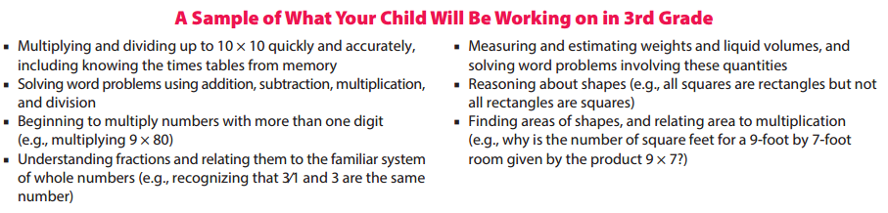

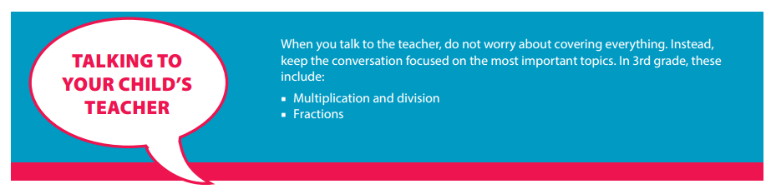

**Help Your Child Learn at Home**

Try to create a quiet place for your child to study, and carve out time every day when your child can concentrate. You should also try to sit down with your child at least once a week for 15 to 30 minutes while he or she works on homework. This will keep you informed about what your child is working on, and it will help you be the first to know if your child needs help with specific topics. Additionally, here are some activities you can do with your child to support learning at home:

*Look for “word problems” in real life. Some 3rd grade examples might include:*

* Notice those everyday occasions when you find yourself using your times tables — such as to determine how many days there are in four weeks. Ask your child for the answer.
* Involve your child when you notice yourself using division to “work backward” in the times tables — such as determining how many candies each child will get if 36 candies are shared equally among nine children at a party.

Resource: <http://www.pta.org/parents/>

**Third Grade**

Nine Week Checkpoints for Parents and Students



|  |  |
| --- | --- |
| **First Nine Weeks** | **Second Nine Weeks** |
| *Helpful websites to help students master the first and second nine week concepts:*  [*https://www.khanacademy.org/commoncore/grade-3-NBT*](https://www.khanacademy.org/commoncore/grade-3-NBT)  [*https://www.khanacademy.org/commoncore/grade-3-OA*](https://www.khanacademy.org/commoncore/grade-3-OA)  [*https://www.khanacademy.org/commoncore/grade-3-MD*](https://www.khanacademy.org/commoncore/grade-3-MD) | |
| *Students should know and be able to:*   * Explain what the three digits of a three-digit number represent * **Fluently add and subtract within 1,000 using strategies** * Say from memory every multiplication fact 0-10 * Round to the nearest 10 and 100 * Represent and interpret data with bar graphs and line plots | *Students should know and be able to:*   * Use addition, subtraction, multiplication, and division to solve two-step word problems * Use multiplication and division to solve problems * **Fluently multiply and divide within 100 using strategies1** * Multiply and divide whole numbers * Find the area of plane figures |
| **Third Nine Weeks** | **Fourth Nine Weeks** |
| *Helpful websites to help students master the third and fourth nine week concepts:*  [*https://www.khanacademy.org/commoncore/grade-3-G*](https://www.khanacademy.org/commoncore/grade-3-G)  [*https://www.khanacademy.org/commoncore/grade-3-NF*](https://www.khanacademy.org/commoncore/grade-3-NF)  [*https://www.khanacademy.org/commoncore/grade-3-MD*](https://www.khanacademy.org/commoncore/grade-3-MD) | |
| *Students should know and be able to:*   * Explain what fractions represent * Explain fractions using a number line * Create equivalent fractions * Compare fractions * Divide shapes into equal parts * Find the perimeter of place figures | *Students should know and be able to:*   * Tell time to the nearest minute * Calculate a given amount of time (elapsed time) * Solve real world problems using time * Understand data with bar graphs and line plots * Solve one and two-step word problems using volume and mass |

*1By end of year, know with* ***conceptual understanding*** *from memory all products of two one‐digit numbers.*